# How To Use The Brewers Association Twitter Dashboard

#### Overview:

The data represented in this dashboard is current up to February 4, 2018. For each of the three twitter handles, roughly 3500 of the most recent tweets were pulled. This dashboard allows users to investigate the performance of each of the handles as a whole in various ways.

#### User Controlled Parameters:

As a part of the interactive dashboard, users have the ability to select a filter data through dropdowns and selectors scattered throughout the viz.

There are two primary filters located near the top of the dashboard under the title (Success Measure and Handle). These variables are fairly straight forward and affect all of the views on the dashboard.

There are two secondary parameters that are also included within the view, the first located under the view title “Which Hashtags Increase Retweets/Favorites”. This parameter sorts, in descending order, the hashtags on either the number of tweets corresponding to each hashtag or the Average of the success metric.

The final secondary parameter is located in the upper right hand corner of the view labeled “What is the # Week average of Retweets/Favorites”, and changes the number of weeks included in the moving average of the success metric.

#### View Descriptions:

**What is the best time to tweet to receive Retweets/Favorites?**

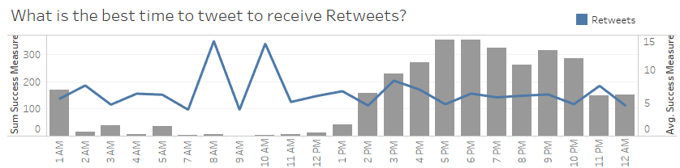In this view the user can take a look at when each handle is tweeting based on the entire corpus of tweets collected. The x-axis represents the hour of the day (there is a possibility that the hour representation is based on some universal time zone that twitter uses, this can be corrected). The y-axis represents two measures, the first represented in bars and the left hand axis is the sum of tweets produced by the handle, and the second represented by the blue line and the right hand axis is the average sum of the selected success measure at that time.

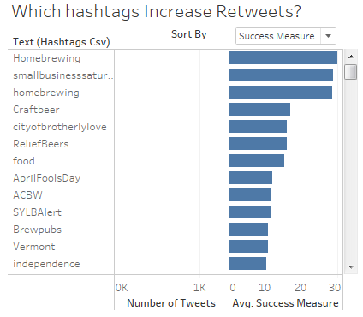**Which hashtags increase Retweets/Favorites?**

This view allows the user to look into which hashtags have had greater success or vice versa. This view is fairly simple and represents an exhaustive list of all hashtags as they are show within the tweet. Given the large volume of hashtags a scroll bar is included to investigate further. Two separate bar charts are used in this view giving the user the ability to see both the number of tweets containing the hashtag as well as the average of the success measure. As mentioned before the hashtags can be sorted in descending order on either value with the *Sort By* parameter.

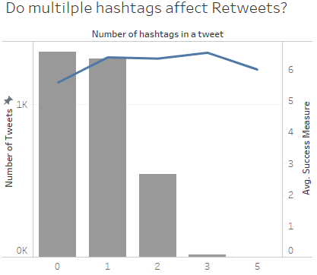**Do multiple hashtags affect Retweets/Favorites?**

In this view the user has the ability to investigate what affect multiple hashtags have on tweets for the selected Twitter handle. The x-axis represents the number of hashtags in a tweet. Similar to the first view (What is the best time to tweet to receive Retweets?) the y-axis represents two variables. The first again represented with a bar and the left hand axis is the number of tweets represented by the number of hashtags. The second represented again by the line and right hand axis is the average of the success measure.

**What is the #-week average of Retweets/Favorites?**

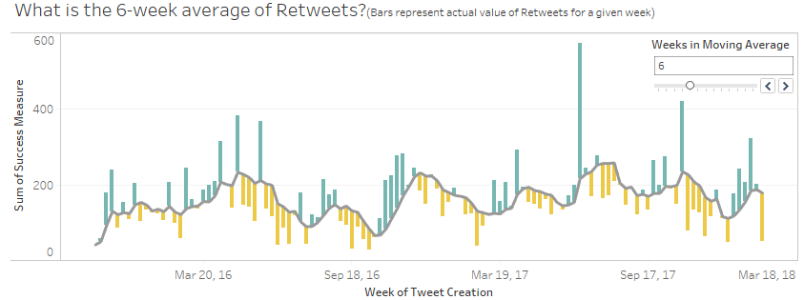This view give the viewer the opportunity to see the success of twitter campaigns over multiple weeks. The x-axis in this view represents the week of tweets, and the y-axis represents the sum of the success measure. Reading this view may be intimidating at first, but is simple to comprehend with very little coaching.

The line in this chart is the moving average of the success measure. By default this is set to 6 weeks, meaning that the currently along with the previous 5 weeks sum of the success measure are averaged for a given week. This can be altered to increase or decrease the number of weeks included with the slider in the upper right hand corner.

The bars represent the actual value of the success measure, in essence the viewer can think of these bars as reaching out from the moving average to the actual value for a given week. If the week’s value is greater than the moving average for that week then the bar is colored blue-green, and if it is less then it is yellow.

#### Tool Tips:

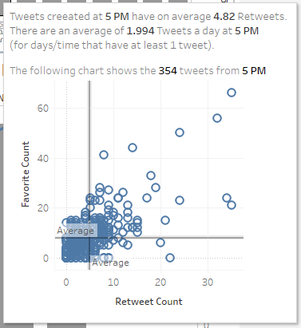Most views on this dashboard have a similar tool tip the one at the right. They are visible upon hovering over a given data point. Within the tooltip adaptive text describes the data point as well as shows the representative tweets on a scatter plot where Favorite counts are the y-axis and Retweet counts are on the x-axis. In addition an average line is displayed for both for additional convenience.

Within the *What is the #-week average of Retweets/Favorites?* View a separate although still informative tooltip has been created (below). Again to access the tool tip it is required to hover the users mouse over a given data point. Also similar to the other tool tip the top o

